

***School of Mechanical & Manufacturing Engineering (SMME),***

***National University of Science and Technology (NUST),***

***Sector H-12, Islamabad***

Program: BE-Aerospace Section: AE-01

Session: Spring 2024 Semester: 2nd

Course Title: Engineering Drawing AE-103

Assignment # 1

***“Orthographic Projection”***

***Name: IKHLAS JAMSHAID***

***CMS:*** 454122

**LAB OBJECTIVE**Top of Form

The primary objective of this engineering drawing assignment was to learn the principles and practices of orthographic projection, particularly focusing on the application of the first angle view method within the AutoCAD environment. This assignment allowed me to equip myself with the skills necessary to accurately represent three-dimensional objects in two dimensions, fostering an understanding of projection systems and technical drawing conventions.

**DEFINITIONS:**

* **Orthographic Projection**: A fundamental technique used in technical drawing to represent the three-dimensional form of an object in two dimensions by projecting its views onto perpendicular planes.
* **First Angle Projection:** A method of orthographic projection wherein the object is situated in the first quadrant of 3D space, and its views are projected onto planes positioned between the object and the observer.
* **Visible Edges:** The lines representing the outlines and features of the object that are directly visible in the orthographic projections.
* **Hidden Edges:** Lines representing features of the object that are obscured from direct view in the given projections but are essential for conveying complete information about the object's geometry.
* **Centre Lines:** Lines indicating the center of symmetry, rotation, or other significant features of cylindrical or symmetrical parts.

**KEY CONCEPTS:**

* **Projection Systems**: Understanding the fundamental differences between first angle and third angle projection systems and their application in technical drawings. Recognizing the placement of object and observer in 3D space relative to the projection planes.
* **Division of Sheet**: Techniques for effectively dividing the drawing sheet to accommodate multiple views, title blocks, and other necessary elements while maintaining clarity and organization.

***How to Divide a Sheet***

*• Vertical Spacing =[Total Height of sheet(HS ) –(Height of Object Ho + Depth of object Do ) ]/ 3*

*• Vertical Spacing= (HS -Ho+Do )/3 • Horizontal Spacing=[Total Width of sheet(WS ) –(Width of Object Wo + Depth of object Do ) ]/ 3*

*• Horizontal Spacing= (WS -Wo+Do )/3*

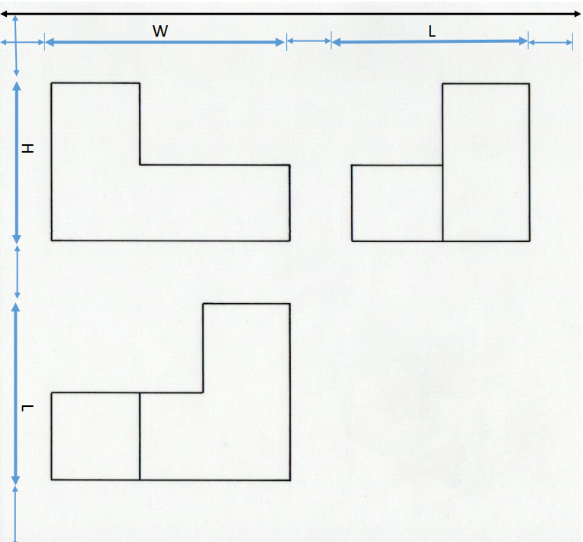

* **Projection Symbols**: Familiarizing oneself with the standard symbols used to denote first and third angle projections, and comprehending their significance in communicating projection methods.
* **Practical Application**: Applying theoretical knowledge to practical scenarios by accurately representing given objects in AutoCAD using the first angle projection method. Emphasis on precise alignment, differentiation of line types, and adherence to projection principles.

**PROCEDURE**

**Preparation:** Set up the AutoCAD environment, configure necessary settings, and establish layers for visible edges (white), hidden edges (red), and center lines (blue). As I did in my drawing

**Projection Creation:**

Generate the front, top, and side views of the object using the principles of first angle projection.

Carefully position each view relative to the others, adhering to the conventions of first angle projection.

**Line Differentiation:**

Assign appropriate colors and linetypes to differentiate between visible, hidden, and center lines, ensuring clarity and readability of the drawing.

**Layout Finalization:**

Arrange the projection views systematically within the drawing space, incorporating necessary dimensions, title block, and other annotations.

**Review and Adjustment:**

Conduct a thorough review of the drawing to ensure accuracy and adherence to first angle projection principles.

Make necessary adjustments to address any discrepancies or inaccuracies.

**SPECIFIC STEPS ; How I made My assignment:**

* **Creation of A3 Size Drawing Board**:
  + I began by creating an A3 size drawing board to ensure that my drawing dimensions align with standard printing sizes. This step provides a solid foundation for the rest of my drawing activities and ensures consistency in layout.
* **Title Box Formation**:
  + Next, I designed and inserted a title box of specific dimensions as shown in the provided figure. This title box serves as a standardized area for including essential project information such as title, date, scale, and author details. By adhering to specific size requirements, I ensure uniformity across my drawings.

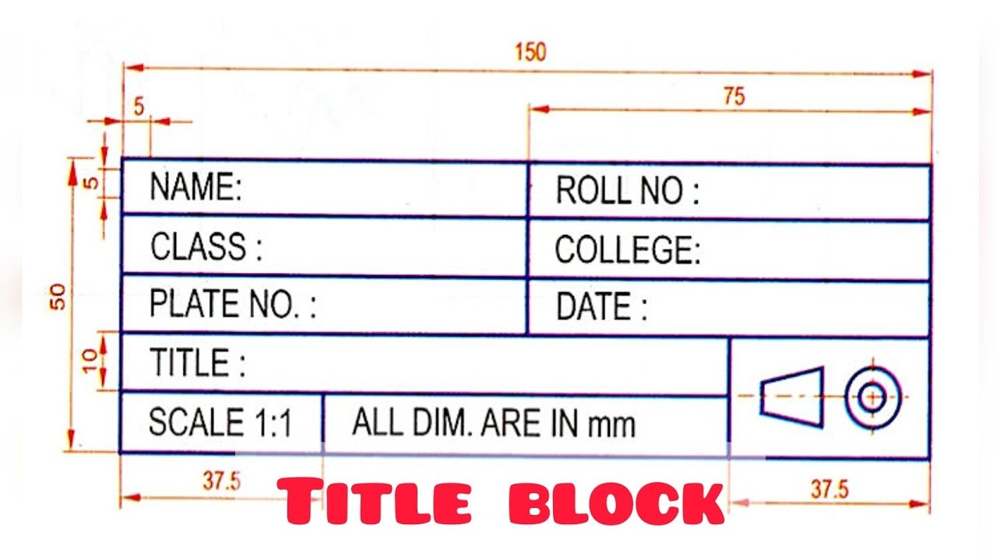

* **Sheet Division**:
  + I divided the drawing sheet according to the provided diagram, creating individual spaces for each orthographic projection view. Ensuring linear gaps between all views is crucial for maintaining clarity and preventing overlap. Proper sheet division helps me organize the various views systematically and optimize space utilization within the drawing layout.

* **Drawing Visible Edges**:
  + I began drawing the visible edges of the object in the front, top, and side views. These visible edges represent the outlines and features of the object that are directly visible in the orthographic projections. Using appropriate lineweights and line types, I distinguished visible edges from other components of the drawing.
* **Drawing Center Lines**:
  + I created center lines for the object's symmetrical or rotational features. These center lines help identify center points and axes of symmetry within the object, facilitating accurate representation and alignment in the orthographic projections. Placing center lines on a separate layer (Layer 2) ensures they are distinct from visible edges and hidden lines.
* **Drawing Hidden Lines**:
  + Next, I drew hidden lines to represent features of the object that are obscured from direct view in the projections. These hidden lines convey additional information about the object's internal structure or hidden components. Placing hidden lines on a designated layer (Layer 3) with distinct lineweights or linetypes helps differentiate them from visible edges and center lines.
* **Dimensioning**:
  + Finally, I added dimensions to the orthographic projections to provide specific measurements and clarify the size and scale of the object. Dimensioning ensures accurate representation of spatial relationships and allows for interpretation of the object's size, shape, and features. Applying dimensioning standards and practices ensures consistency and readability throughout the drawing.

**SCREEN SHOTS**

***Drawing 1:***

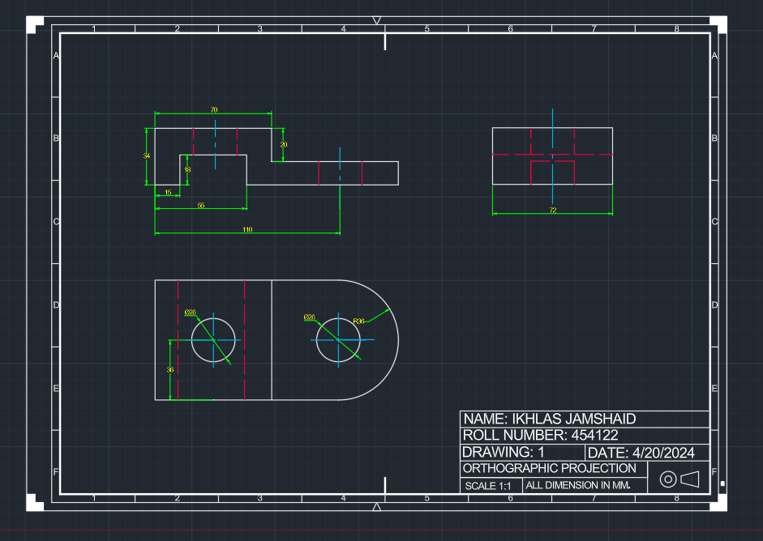

***Drawing 2:***

***Drawing 3:***

**CONCLUSION**

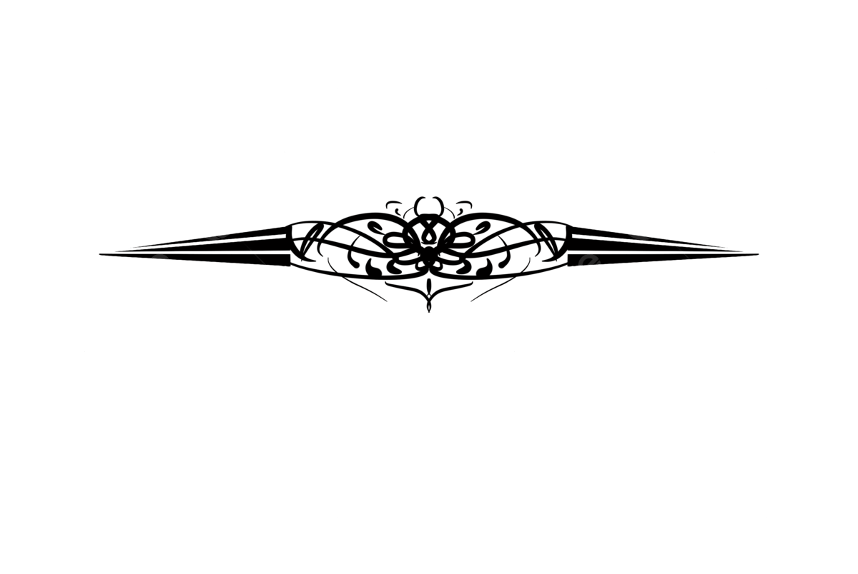 In conclusion, this assignment served as a comprehensive exploration of orthographic projection techniques within the AutoCAD environment. By applying the principles of first angle projection, students gained valuable insights into the meticulous process of representing three-dimensional objects in two dimensions. The exercise not only enhanced proficiency in AutoCAD but also deepened understanding of projection systems, line conventions, and layout organization. Through practical application and theoretical comprehension, students developed essential skills essential for creating precise technical drawings in engineering and design disciplines.